CYBERSECURITY AND CYBER THREATS AND ATTACKS
FACILITATOR GUIDE

Module Code | 252901001-KM-03
NQF Level | 5
Credits | 12
Curriculum Code | 252901001
Qualification Title | Occupational Certificate: Cybersecurity Analyst
SAQA QUAL ID | 118986

Name
Contact Address
Telephone (H)
Telephone (W)
Facsimile
Cellular
E-mail

Note to the learner
This Learner Guide provides a comprehensive overview of the module. It is designed to improve the skills and knowledge of learners, and thus enabling them to effectively and efficiently complete specific tasks.
Entry Requirements

- NQF 4
Provider Accreditation Requirements for the Knowledge Module

Physical Requirements
- The provider must have lesson plans and structured learning material or provide learners with access to structured learning material that addresses all the topics in all the knowledge modules as well as the applied knowledge in the practical skills.
- QCTO/ MICT SETA requirements

Human Resource Requirements:
- Lecturer/learner ratio of 1:20 (Maximum)
- Qualification of lecturer (SME):
    - NQF 6 in industry recognised qualifications with 1 years’ experience in the IT industry
    - CYBERSECURITY vendor certification
- Assessors and moderators: accredited by the MICT SETA
Legal Requirements
- Legal (product) licences to use the software for learning and training
- OHS compliance certificate
- Ethical clearance (where necessary)
Module Purpose
The main focus of the learning in this knowledge module is to build an understanding of principles of cybersecurity and Ethical Hacking and the types of threats and attacks and the respective risk

Topic elements to be covered include
The learning will enable learners to demonstrate an understanding of:
- KM-03-KT01: Information security Governance and compliance
- KM-03-KT02: Information security
- KM-03-KT03: Foot printing and Reconnaissance
- KM-03-KT04: Scanning Networks
- KM-03-KT05: Enumeration
- KM-03-KT06: Vulnerability Analysis
- KM-03-KT07: System Hacking
- KM-03-KT08: Malware Threats
- KM-03-KT09: Sniffing
- KM-03-KT10: Social Engineering
- KM-03-KT11: Denial-of-Service
- KM-03-KT12: Session Hijacking
- KM-03-KT13: Evading IDS, Firewalls, and Honeypots
- KM-03-KT14: Hacking Web Servers
- KM-03-KT15:SQL Injection
- KM-03-KT16: Hacking Wireless Networks
- KM-03-KT17: Hacking Mobile Platforms
- KM-03-KT18: IoT Hacking
- KM-03-KT19: Cloud Computing
- KM-03-KT20: Cryptography
- KM-03-KT21: Cyber incident response and management

Venue, Date and Time:
Consult your facilitator should there be any changes to the venue, date and/or time.
Refer to your timetable
Assessments

The only way to establish whether you are competent and have accomplished the learning outcomes is through continuous assessments. This assessment process involves interpreting evidence about your ability to perform certain tasks. You will be required to perform certain procedures and tasks during the training programmer and will be assessed on them to certify your competence.

This module includes assessments in the form of self-evaluations/activities and exercises. The exercises, activities and self-assessments will be done in pairs, groups or on your own. These exercises/activities or self-assessments (Learner workbook) must be handed to the facilitator. It will be added to your portfolio of evidence, which will be proof signed by your facilitator that you have successfully performed these tasks.

Listen carefully to the instructions of the facilitator and do the given activities in the time given to you.

Question
1
Explain the importance of compliance with governance framework in
Security Standards
To make cybersecurity measures explicit, the written norms are required. These norms are known as cybersecurity standards: the generic sets of prescriptions for an ideal execution of certain measures. The standards may involve methods, guidelines, reference frameworks, etc. It ensures efficiency of security, facilitates integration and interoperability, enables meaningful comparison of measures, reduces complexity, and provide the structure for new developments.
A security standard is "a published specification that establishes a common language, and contains a technical specification or other precise criteria and is designed to be used consistently, as a rule, a guideline, or a definition." The goal of security standards is to improve the security of information technology (IT) systems, networks, and critical infrastructures. The Well-Written cybersecurity standards enable consistency among product developers and serve as a reliable standard for purchasing security products.
Security standards are generally provided for all organizations regardless of their size or the industry and sector in which they operate. This section includes information about each standard that is usually recognized as an essential component of any cybersecurity strategy.
ISO
ISO stands for International Organization for Standardization. International Standards make things to work. These standards provide a world-class specification for products, services and computers, to ensure quality, safety and efficiency. They are instrumental in facilitating international trade.
ISO standard is officially established On 23 February 1947. It is an independent, non-governmental international organization. Today, it has a membership of 162 national standards bodies and 784 technical committees and subcommittees to take care of standards development. ISO has published over 22336 International Standards and its related documents which covers almost every industry, from information technology, to food safety, to agriculture and healthcare.
ISO 27000 Series
It is the family of information security standards which is developed by the International Organization for Standardization and the International Electrotechnical Commission to provide a globally recognized framework for best information security management. It helps the organization to keep their information assets secure such as employee details, financial information, and intellectual property.
The need of ISO 27000 series arises because of the risk of cyber-attacks which the organization face. The cyber-attacks are growing day by day making hackers a constant threat to any industry that uses technology.
The ISO 27000 series can be categorized into many types. They are-
ISO 27001- This standard allows us to prove the clients and stakeholders of any organization to managing the best security of their confidential data and information. This standard involves a process-based approach for establishing, implementing, operating, monitoring, maintaining, and improving our ISMS.
ISO 27000- This standard provides an explanation of terminologies used in ISO 27001.
ISO 27002- This standard provides guidelines for organizational information security standards and information security management practices. It includes the selection, implementation, operating and management of controls taking into consideration the organization's information security risk environment(s).
ISO 27005- This standard supports the general concepts specified in 27001. It is designed to provide the guidelines for implementation of information security based on a risk management approach. To completely understand the ISO/IEC 27005, the knowledge of the concepts, models, processes, and terminologies described in ISO/IEC 27001 and ISO/IEC 27002 is required. This standard is capable for all kind of organizations such as non-government organization, government agencies, and commercial enterprises.

Question
2

Discuss Information security controls
What are information security controls?
According to NIST (the National Institute of Standards and Technology), security controls are defined as “the safeguards or countermeasures prescribed for an information system or an organization to protect the confidentiality, integrity, and availability of the system and its information.”
That means that any countermeasure used to keep a computer, device, network, or safe from a data breach or another attack is a countermeasure.
That may seem extremely broad, but information security controls are often categorized, both by type and by the goals of the countermeasure. What does that mean? Below is a listing of information security controls by type:
- Physical controls: Locks on doors that keep intruders from devices, the ability to remove a device from a network, and access control to physical equipment are all physical controls.
- Administrative controls:
- information security awareness, and training are administrative controls.
- Technical controls: Items that use technology to combat attacks, like authentication, antivirus software, and firewalls are technical controls.
- Legal and regulatory or compliance controls: Privacy legislation or information security frameworks are legal or regulatory controls.
When controls are classified by a goal, however, the list looks a little different:
- Preventive controls: Intended to prevent an incident from occurring, such as good cyber hygiene, network segmentation, and user authentication.
- Detective controls: Tools used during an incident to respond to a breach, such as anti-malware software, a ransomware response plan, or security ratings.
- Corrective controls: After the event, corrective controls limit the extent of any damage caused by the incident, such as cybersecurity insurance or new response plans.
What security controls does my organization need?
No one organization will implement every single information security control. Some may be redundant and some might not be relevant to your organization or your networks, but every organization needs some of the above.
There are several security standards and frameworks that provide a starting point for organizations when it comes to security best practices and controls.
- NIST, mentioned above, offers a free, voluntary cybersecurity framework consisting of standards, guidelines, and practices to promote the protection of an organization’s critical infrastructure. It lists more than 100 individual controls a company can use to mitigate risk.
- Another standard, the ISO/IEC 27001, is offered by the International Organization for Standardization (ISO) and the International Electrotechnical Commission (IEC). Thai international standard identifies 114 controls in 14 groups, ranging from policies to incident management.
- The SANS CIS Controls are a recommended set of actions for cyber defense that provide specific and actionable ways to stop attacks.
- COBIT5 is a proprietary control set published by ISACA which is based on five principles of security.

Question
3
Explain how risks and mitigation of scanning networks are interrogated
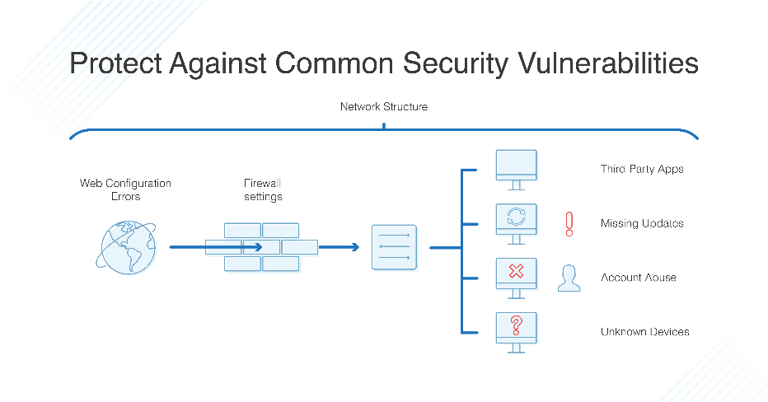
What is the importance of Network Vulnerability Scanning?
Network vulnerability scanning is an essential part of any IT department’s security infrastructure. Although it’s an essential part of any IT department’s security infrastructure, there is still some confusion as to what network vulnerability scanning really is, as well as what it does, and why you might use it.
Network vulnerability scanning is an integral part of the security assessment process of any network or system. It is a complex process, given the number of systems that need to be scanned, so it is best to approach this in an organized and systematic way.
Network vulnerability scanning is a great way to gauge the security of your network. It helps you identify the weak points in your system that you need to patch up. This blog will take you through a complete guide to understanding these scans and how you can use them.
Understanding Top 3 Network Vulnerabilities
Most of the security breaches that we hear about in the news are network breaches. If a network is vulnerable to attack, the network is vulnerable to network vulnerabilities. It is at the network level that many attacks begin, including traditional breaches and sophisticated malware attacks.
It is a good idea to understand network vulnerabilities so that you can take steps to prevent them. There are three main network vulnerabilities that you will want to understand:
1. Misconfigured devices
Misconfigured devices are easily accessible to attackers through which they can access other devices in the network. In a majority of cases, attackers use misconfigured devices in order to expand their presence within a target network. This is also a good way to collect privileged information. All it takes is a single misconfigured device to compromise the entire network.
2. Unpatched systems
Organizations often neglect updating their systems and this makes them vulnerable to attacks. This security hole can be easily exploited by attackers. The unpatched systems are open to vulnerabilities and cybercriminals can easily send in viruses, Trojans and Ransomware.
This increases the risk to the organizations and the customers as well. At Astra, we have come across many organizations that have not updated their systems for the last several years. This has led to the creation of a vast number of vulnerabilities that can be exploited by attackers.
3. Human error
Humans are the weakest link in the security chain. It’s quite easy for an attacker to trick employees to gain access to the network. For example, social engineering is one of the most common methods used by attackers to gain access to the network.
Best Practices to avoid Network Security Risks
Network security risks are a serious threat to any business. It is important to take preventive measures to avoid these risks and ensure that your business functions smoothly without any interruptions. The following are four best practices that you can implement to ensure a secure network.
1. Segmentation of network
Segmentation of network means that you separate the network into different segments. This way you can provide security to your network. You need to ensure that the internal network is not connected to the external network. The machines present in the internal network are not accessible from the external network.
2. Network Vulnerability Scanning
There is no way to avoid security threats, but you can minimize these threats by performing network vulnerability scanning on a regular basis. The scanning helps in detecting the vulnerabilities in the network and removing them.
3. Backup
Back up your data on a regular basis so that you can recover it if you face any data loss due to any security breach.
4. Install an IPS/IDS
Make sure to have an IPS or an IDA installed on your network. This software provides the necessary protection against malicious attacks on the network

Question
4

Describe how Risks and mitigation of vulnerability analysis concepts and objectives are interrogated

What is Vulnerability Analysis, and How Does It Work?
Did you know that 60% of all data breaches were made possible by unpatched vulnerabilities (Willis, V. 2019)? That staggering figure shows why a vulnerability assessment is critical to any cybersecurity strategy.
There is no denying that every system has vulnerabilities. Detecting them quickly is key to properly identifying, prioritizing, and mitigating them. However, as organizational architecture grows more complex, it’s difficult to fully understand it without utilizing a systematic vulnerability analysis.
Read on to learn why vulnerability analysis is important and how it can be utilized to help your organization overcome its cybersecurity risks.
What Is Vulnerability Assessment?
The purpose of vulnerability analysis, or vulnerability assessment, is to create a structured process for discovering vulnerabilities in a system, prioritizing them, and creating a mitigation strategy. Cybersecurity professionals often use vulnerability analysis alongside other detection methods, such as penetration testing, to better understand an organization’s system and its most significant risks.
Since there are multiple uses of vulnerability analysis, there are many different types of assessments to choose from (Computer Security Resource Center, 2022):
- Application assessments to determine vulnerabilities within the web applications your organization uses.
- Network assessments that require a review of your procedures and policies to protect you against unauthorized access.
- Database assessments to discover configuration issues, unprotected data, and other vulnerabilities within your infrastructure.
- Host assessments to reveal vulnerabilities of your critical servers that could impact operations and security if not properly tested and protected.
Most organizations need to run a combination of these assessments regularly. As with most cybersecurity practices, you need to invest time into vulnerability assessments on a routine basis and adjust practices and policies accordingly as an organization’s architecture and cyberthreats evolve.
Vulnerability Assessment Checklist
Even if you’ve conducted vulnerability assessments in the past, staying up to date on the best practices of vulnerability assessment methodology helps you get the most out of the process. As such, here’s a checklist to follow that ensures an assessment is thorough, efficient, and productive (New York State Department of Health, 2022):
- Define desirable business outcomes in advance: Some organizations make certain processes, such as pen tests and vulnerability assessments, mandatory and routine. That is okay, but desirable outcomes need to be defined before every assessment, or it may not be as productive or impactful as a team hopes. Prioritizing risks, achieving compliance, preventing data breaches, or reducing recovery time are all reasonable goals.
- Prioritize before you assess: While a vulnerability assessment can help you prioritize risks, you must also prioritize your assets before moving forward. Conducting a thorough assessment can be an exhaustive process, especially for the first time, so you must first assess the most important components. This also means understanding the different types of assessments you can conduct and how to best structure them before you dive in.
- Prepare for your assessment: Rarely is a vulnerability assessment run with the click of a button. Technical preparation involves conducting meetings, constructing a threat model, interviewing your system developers, and verifying the details of your test environment. Both passive and active vulnerability testing is valuable but knowing when and where to use each VA testing method is essential for success. In addition to knowing your testing options, you need to understand the environment you’re working in and the biggest risks you must prioritize, explore, and mitigate.
- Review as you go: During the test, you must manually check your results to filter out false positives and prioritize true positives. It would help if you also recorded the steps taken and collected evidence to ensure that the process for getting a given result is fully understood and repeatable, as you’ll need to explore it more closely later.
- Create detailed reports after each assessment: A vulnerability assessment is only as valuable as the knowledge it provides, so creating a comprehensive account alongside each assessment is critical to ensuring information is remembered, shared, and used to take action. A complete description of all vulnerabilities, associated risk levels, mitigation steps, and remedies should be compiled.
- Invest in continued education and training: Aside from continuing your education through certification programs, retaining the results and reports of each vulnerability assessment you conduct proves valuable for teaching yourself and others how to better prevent and respond to incidents that may occur in the future. Detailed reports are also helpful in communicating issues to non-technical stakeholders, such as those in the C-suite who need to be aware of significant risks and strategies for dealing with them.
If you stick to these best practices the next time you plan a vulnerability assessment, you’re sure to get a lot more out of the process. Of course, getting to the point where you’re confident enough to conduct a vulnerability assessment takes knowledge and hands-on practice, which is why pursuing further education can help prepare you.

Question
5
Outline how risks and mitigation of malware are solved

Implementing Malicious Code Countermeasures
Because malware is so prevalent, it’s important to protect systems. The primary method of protection is antivirus software and an aggressive defense-in-depth strategy. As an overview, the following methods can be implemented as countermeasures against malware:
• Install antivirus software on all systems.
• Install antivirus and antispam software on e-mail servers.
• Install antivirus and content filter software on firewalls.
• Keep all antivirus software up to date.
• Keep all systems up to date.
• Educate users.

Question
6
Explain risks associated with social engineering
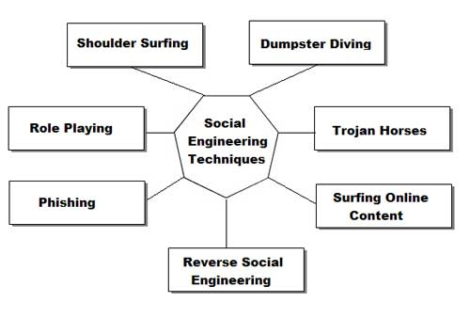
What is Social Engineering?
Social engineering is a term that describes a non-technical kind of intrusion that relies heavily on human interaction and often involves tricking other people to break normal security procedures.
Social engineering, in the context of information security, is understood to mean the art of manipulating people into performing actions or divulging confidential information. This is a type of confidence trick for the purpose of information gathering, fraud, or gaining computer system access. It differs from traditional cons in that often the attack is a mere step in a more complex fraud scheme.
“Social engineering” as an act of psychological manipulation had previously been associated with the social sciences, but its usage has caught on among computer and information security professionals.
Well known attacks
All social engineering techniques are based on specific attributes of human decision-making known as cognitive biases. These biases, sometimes called “bugs in the human hardware,” are exploited in various combinations to create attack techniques.
Pretexting
Pretexting (adj. pretextual), also known in the UK as blagging or bohoing, is the act of creating and using an invented scenario (the pretext) to engage a targeted victim in a manner that increases the chance the victim will divulge information or perform actions that would be unlikely in ordinary circumstances. An elaborate lie, it most often involves some prior research or setup and the use of this information for impersonation (e.g., date of birth, Social Security number, last bill amount) to establish legitimacy in the mind of the target.
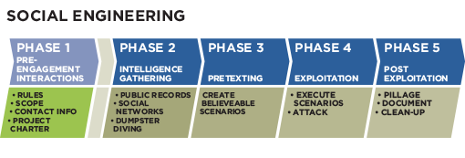
This technique can be used to fool a business into disclosing customer information as well as by private investigators to obtain telephone records, utility records, banking records and other information directly from company service representatives. The information can then be used to establish even greater legitimacy under tougher questioning with a manager, e.g., to make account changes, get specific balances, etc.
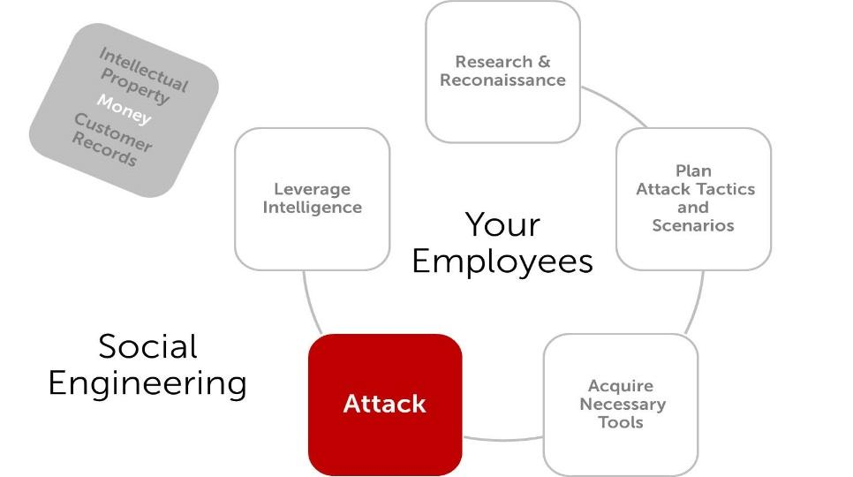
Pretexting can also be used to impersonate co-workers, police, bank, tax authorities, clergy, insurance investigators — or any other individual who could have perceived authority or right-to-know in the mind of the targeted victim. The pretexter must simply prepare answers to questions that might be asked by the victim. All that is needed is a voice that sounds authoritative, an earnest tone, and an ability to think on one’s feet to create a pretextual scenario. There are also other techniques to get from people what attacker wants. One way is to be likable. People are used to do a favor for people they like, so all is needed is use charm, give a few compliments and ask to do what is needed. Other way is better described better in part called Quid pro quo.

Question
7
Give features of risks and mitigation of session hijacking

Session hijacking is defined as taking over an active TCP/IP communication session without the user’s permission. When implemented successfully, attackers assume the identity of the compromised user, enjoying the same access to resources as the compromised user. Identity theft, Information theft, stealing sensitive data are some of the common impacts of session hijacking.
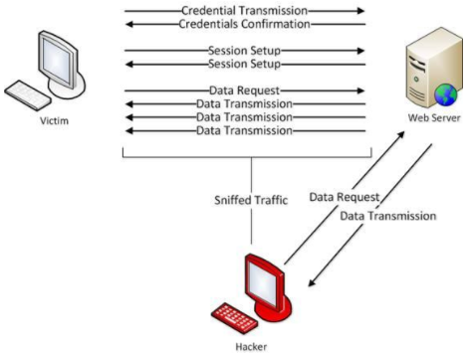
Types of session hijacking attacks:
There are two types of session hijacking depending on how they are done. If the attacker directly gets involved with the target, it is called active hijacking, and if an attacker just passively monitors the traffic, it is passive hijacking.
Active:
The attacker will silence one of the machines, usually the client computer, and take over the clients’ position in the communication exchange between the workstation and the server. The active attack also allows the attacker to issue commands on the network making it possible to create new user accounts on the network, which can later be used to gain access to the network without having to perform the session hijack attack.
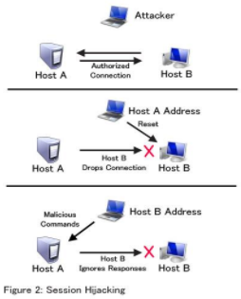
Passive:
In Passive session hijacking attack, the attacker monitors the traffic between the workstation and server. The primary motivation for the passive attack is to monitor network traffic and potentially discover valuable data or passwords.

Question
8
Explain what is mitigation of hacking web servers
Web Server and its Types of Attacks
Websites are hosted on web servers. Web servers are themselves computers running an operating system; connected to the back-end database, running various applications. Any vulnerability in the applications, Database, Operating system or in the network will lead to an attack on the web server. Vulnerability stack of a web server is given below (source: White hat security)
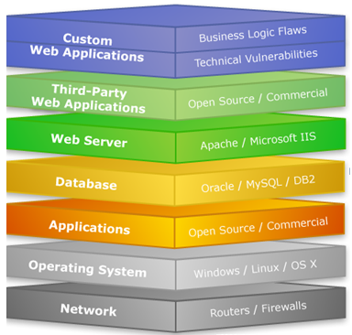
Web Server Attacks types:
DOS attack:
An attacker may cause a denial-of-service attack by sending numerous service request packets overwhelming the servicing capability of the web server, or he may try to exploit a programming error in the application causing a DOS attack.
E.g. buffer overflow attack, SYN flooding, HTTP get Request Flooding, Ping of death.
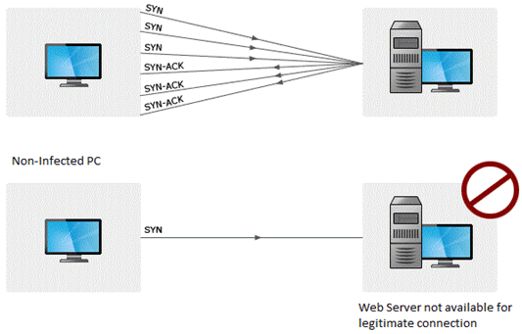
Website Defacement:
SQL injection attacks are used to deface the website. When an attacker finds out that input fields are not sanitized properly, he can add SQL strings to maliciously craft a query which is executed by the web browser. He may store malicious/unrelated data in the database; when the website is requested, it will show irrelevant data on the website, thus displaying a defaced website.

Question
9
Describe the mitigation of hacking wireless networks
Wi-Fi Discovery
Wi-Fi discovery is a process used to learn about WLAN's presence in the environment. WiFi discovery process is not against any law, since you are not acting offensively at any point, you are simply, passively listening to the Wi-Fi frequency bands, using your wireless client.
In order to discover what type of WLAN networks are present, you need to use specific tools that uses wireless hardware and listens on either a 2.4GHz or a 5GHz band. Some of them are built-in to the operating system (they are most often very ineffective for detailed WLAN analysis), and other ones are simple tools, which you can find on the internet. There are hundreds or thousands of tools out there in the market.
I will present to you 2 of them, that I really enjoyed due to its simplicity. What you will discover, while going through these chapters (or you already know it from your experience), the tools delivered for Windows OS have better graphics and some fancy graphical features, opposite to what Linux-based tools provide. But I can promise you, the ones based on Linux provide exactly the same information (just in more text-like format). On the other hand, it is a bit easier to write scripts, that takes outputs of one tools as the input to other ones.
For Windows users, you should have a look at the Xirrus Wi-Fi Inspector (it can be used for free). This is a simple tool that identifies WLANs present in the nearby vicinity. Another tool that performs the same functions in the Windows environment is NetStumbler.
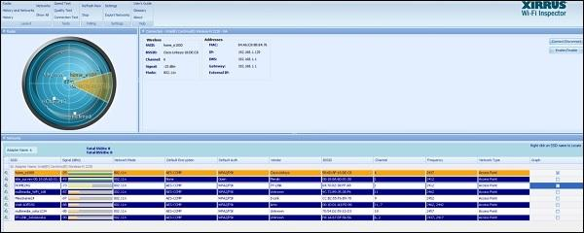
The information which you can extract from the table at the bottom of the above screenshot provides everything you may look for, like SSID name, received signal strength, 802.11 standard used, encryption and authentication set on WLAN, BSSID (MAC address of the AP, in case you would like create a fake AP with the same MAC address) and what channel it operates on. This is a lot of! You can also see, very fancy graphical "radar" showing, how far particular networks are, from your current location - the same information may be read from Signal (dBm) field.
On the other side, when using Linux (I use Kali distribution for penetration testers - you should try as well), the equivalent of that would be a tool called airodump-ng. The set of information, that airodump-ng output to the user is shown in the following screenshot. Also, we have another well-known tool called as Kismet.
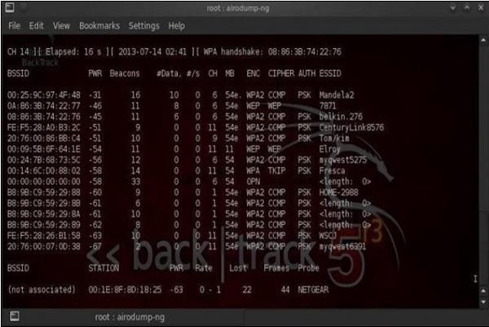
Wardriving
Wardriving is the process of finding a Wireless Network (wireless network discovery) by a person in a car using their personal laptop, smartphone or other wireless client tools. Basically, the intention is to find some free-access wireless network, that malicious user can use without any legal obligations. Examples might be some market, that offer free Wi-Fi, without registration or some hotel that you can just register with fake data.
The method of finding those WLAN's are exactly the same as described above in this wireless discovery section.
GPS Mapping
There is a number of satellites that orbit the globe, each of them sending a low-power radio signal towards the piece of earth it covers. The GPS device that you use, it may be for example a smartphone with google maps application started, receives that signal from multiple satellites at the same time. The device itself combines those signals together and calculate current geographical location on earth.
The idea of GPS mapping is to map a wireless network that the user encounters on the global map of wireless network in reference to its geographical location. One may use the already mentioned Kismet tool to map its wireless network to the geographical location, and then put its coordinates on the google earth map.
There is website on the internet http://wigle.net that you can use to see how many WLAN's are GPS mapped. You can use this website to map GSM cellular network as well.

Question
10
What are IoT attacks?
IoT devices are manufactured to fulfill the general needs of an organization; therefore, they lack strict security protocols. Attackers have been using this advantage to break into the system of an organization through any of the weak IoT devices.
IoT attacks are cyber-attacks that gain access to users' sensitive data with the help of any IoT device. Attackers usually install malware on the device, harm the device, or gain access to further personal data of the company.
For instance, an attacker may gain access to an organization's temperature control system through a security loophole in any IoT device. He can then influence the temperature of the rooms connected to the appropriate device.
What are the IoT attack surface areas?
As discussed, IoT devices are not built with proper security protocols. Hence, they are one of an organization's weakest links and pose a huge security threat. Following are the attacking zones where the attacks originate and compromise sensitive data:
Devices
Various parts of a device raise security threats for an organization, such as the memory, firmware, web interface, physical interface, and networking service of a device. Attackers can take advantage of these and initiate an IoT attack by finding a loophole in the device, such as an outdated component.
Communication channels
Channels that connect IoT devices to one another need to be secured; otherwise, an IoT attack can be easily initiated.
Applications and software
Applications and software connected to IoT devices also pose a threat to the security of the system. It is easy to access the IoT device by compromising the application or the software of the device.

Question
11

What is mitigation of cryptography
Cryptography is the art and science of keeping data secure. Cryptographic services help ensure data privacy, maintain data integrity, authenticate communicating parties, and prevent repudiation (when a party refutes having sent a message). Three major areas of concern: privacy, authentication, and integrity are addressed using Cryptography.
Basic encryption allows you to store information or to communicate with other parties while preventing non-involved parties from understanding the stored information or understanding the communication. Encryption transforms understandable text (plaintext) into an unintelligible piece of data (ciphertext). Decryption restores the understandable text from the unintelligible data. Both functions involve a mathematical formula (the algorithm) and secret data (the key).
Cryptographic Algorithms

Question
12
Outline two types of cryptographic algorithms:
Symmetric key algorithm
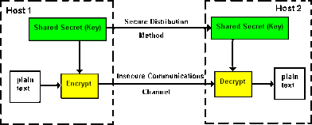

With a secret or symmetric key algorithm, the key is a shared secret between two communicating parties. Encryption and decryption both use the same key. The Data Encryption Standard (DES) and the Advanced Encryption Standard (AES) are examples of symmetric key algorithms and typical key sizes are 64, 128, or 192 bits.
There are two types of symmetric key algorithms:
- Block ciphers: In a block cipher, the actual encryption code works on a fixed-size block of data. Normally, the user's interface to the encrypt/decrypt operation will handle data longer than the block size by repeatedly calling the low-level encryption function. If the length of data is not on a block size boundary, it must be padded.
- Stream ciphers: Stream ciphers do not work on a block basis, but convert 1 bit (or 1 byte) of data at a time.
Asymmetric key algorithm
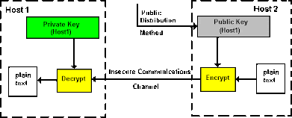

With a public key (PKA) or asymmetric key algorithm, a pair of keys is used. One of the keys, the private key, is kept secret and not shared with anyone. The other key, the public key, is not secret and can be shared with anyone. The keys share a special mathematical property when data is encrypted by one of the keys, it can only be decrypted and recovered by using the other key. The two keys are mathematically related, but it is virtually impossible to derive the private key from the public key. The RSA (after the inventors Rivest, Shamir, and Adelman) algorithm is an example of a public key algorithm.

Typical key sizes for public-key systems are 512 bits, 1,024 and increasingly 2048 bits, or even higher. Public key algorithms are slower than symmetric key algorithms. Applications typically use public key algorithms to encrypt symmetric keys (for key distribution) and to encrypt hashes (in digital signature generation).
Together, the key and the cryptographic algorithm transform the data. All of the supported algorithms are in the public domain. Therefore it is the key that controls access to the data. You must safeguard the keys to protect the data

